**Status 01.04.2015**

**First idea**

Implement a simple game, where blocks fly towards the gamer. The Gamer have to swipe the blocks to gain points.

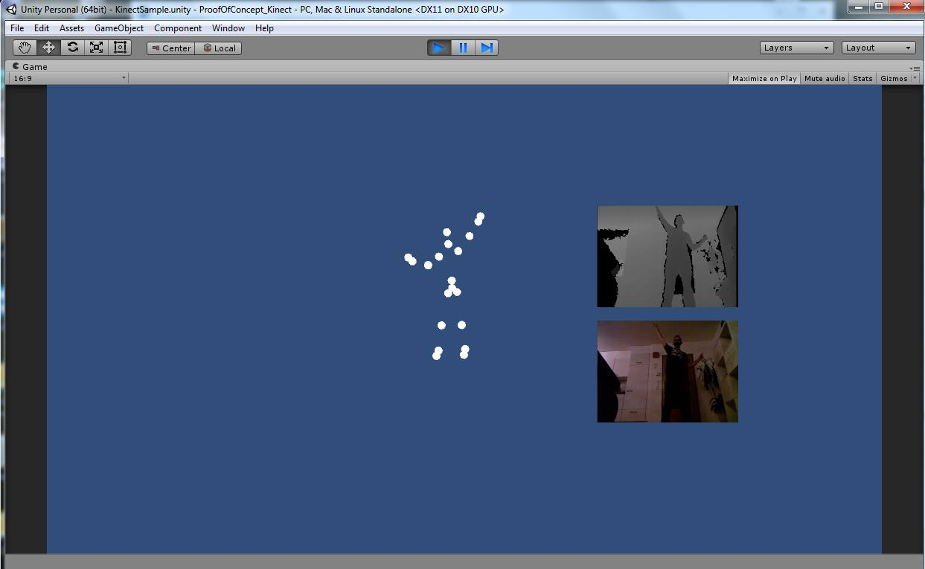We want to use the Kinect to integrate the person’s hands to swipe the blocks and a monitor or the beamer to show the graphical UI. As optional Goal we like to generate the path (movement) of the blocks, out of a MP3 File and also implement a Highscore Board.

**Project situation**

* Connection to Kinect (figure 1)
* tunnel with blocks and collision detection (figure 2)

figure 1 Connection to Kinect

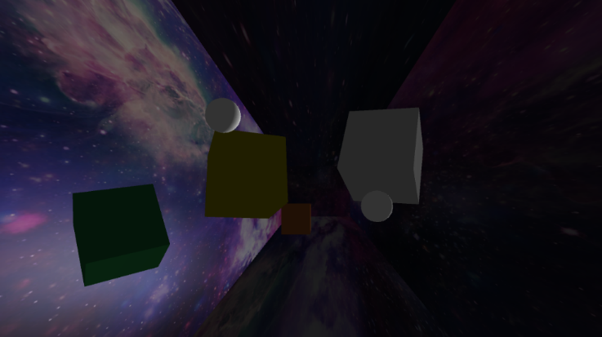**Some changes?**

figure 2 tunnel with blocks and hand-recognition

---

**Used tools**

* Kinect v1
* Unity 5.0
* Vamp plugin SDK with the BBC Vamp Plugin
* Google Code
* Tortoise

**Problems?**

---

**Tutorial definition**

Unity Kinect